Practical No:

Aim : Implement Virtualization using VMware ESXi Server

Phase 1: Downloads & Prerequisites

- Download the ESXi ISO:
  - You will need the VMware vSphere Hypervisor (ESXi) ISO.

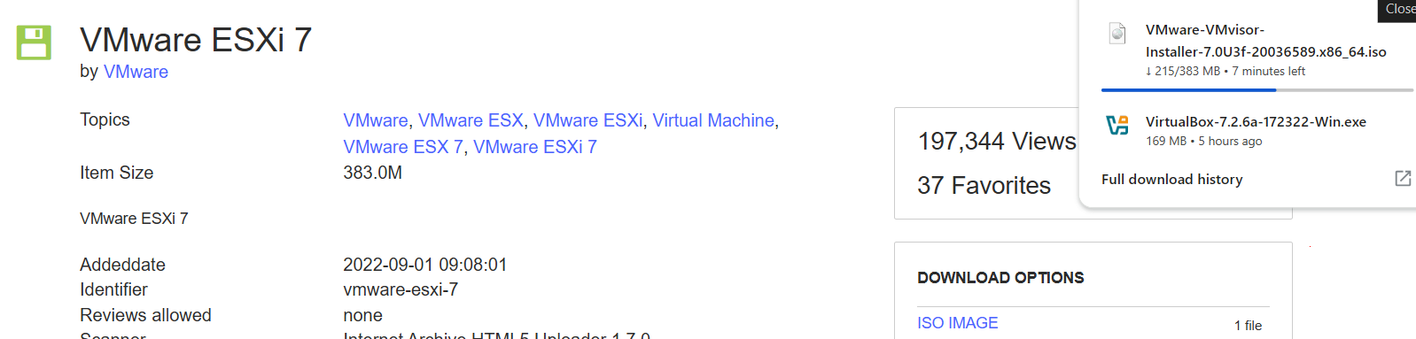
- Ensure VirtualBox is Updated: Make sure you are using the latest version of Oracle VM VirtualBox.
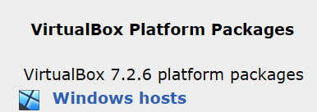

Phase 2: Configure the Nested VM (VirtualBox)

ESXi requires specific hardware flags to install successfully.
- Open VirtualBox and click New.
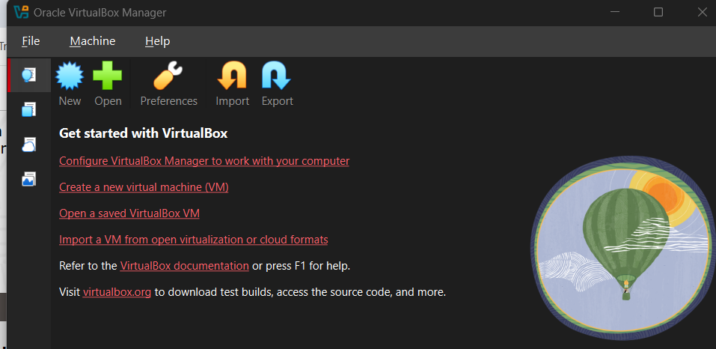
- Name and OS:
  - Name: VMware_ESXi_Lab
  - Type: Linux (or "Other" if VMware is not listed).
  - Version: Other Linux (64-bit).
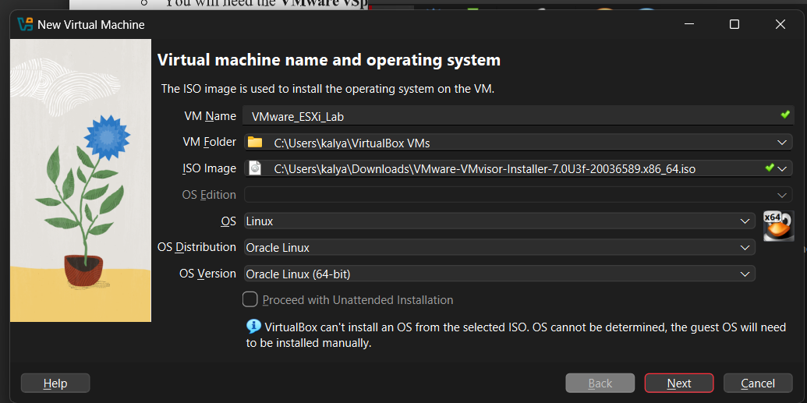

- Hardware Allocation:
  - Base Memory (RAM): ESXi strictly requires a minimum of 4096 MB (4 GB). It will halt the installation if it detects less.
  - Processors: Allocate at least 2 CPUs.
  - Crucial Step: Check the box that says "Enable Nested VT-x/AMD-V"

  - .Hard Disk: Create a dynamically allocated Virtual Hard Disk of at least 20 GB. 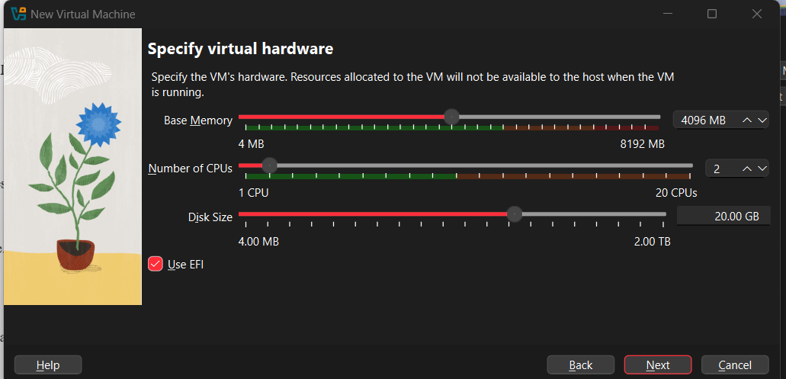
- Network Settings:
  - Select the VM, click Settings →Network.
  - Change "Attached to" to Bridged Adapter so the ESXi host can get an IP address from your network DHCP server.
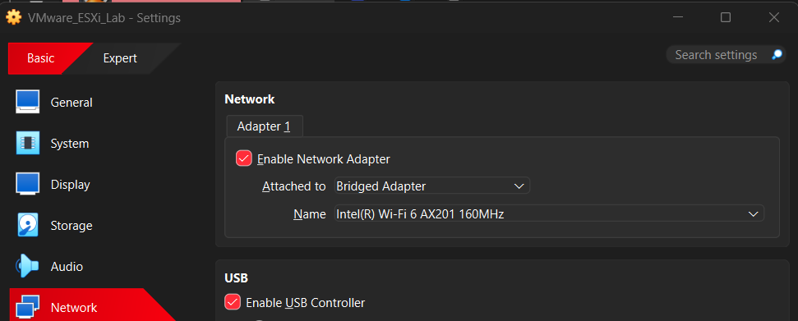
- Storage Settings:
  - Go to Settings →Storage.
  - Click the empty CD icon, then the disk icon on the right, and "Choose a disk file...".
  - Select your downloaded VMware ESXi ISO file.
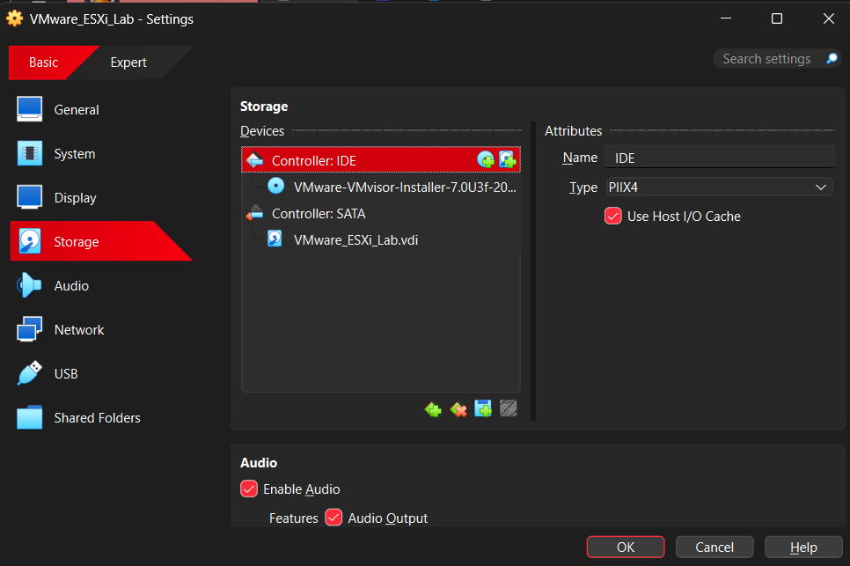

Phase 3: Install the ESXi Hypervisor
- Start the virtual machine. It will automatically boot from the ISO. You will see a black screen with a loading bar loading the ESXi kernel.
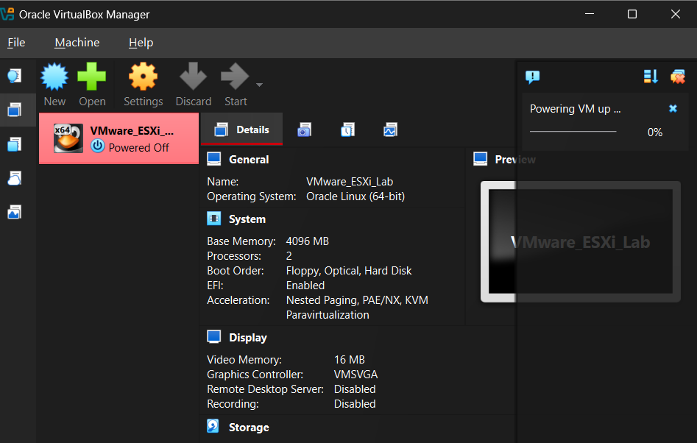
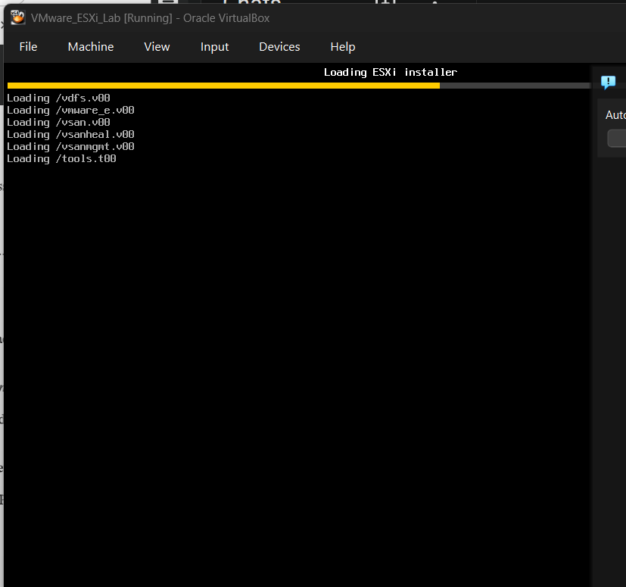
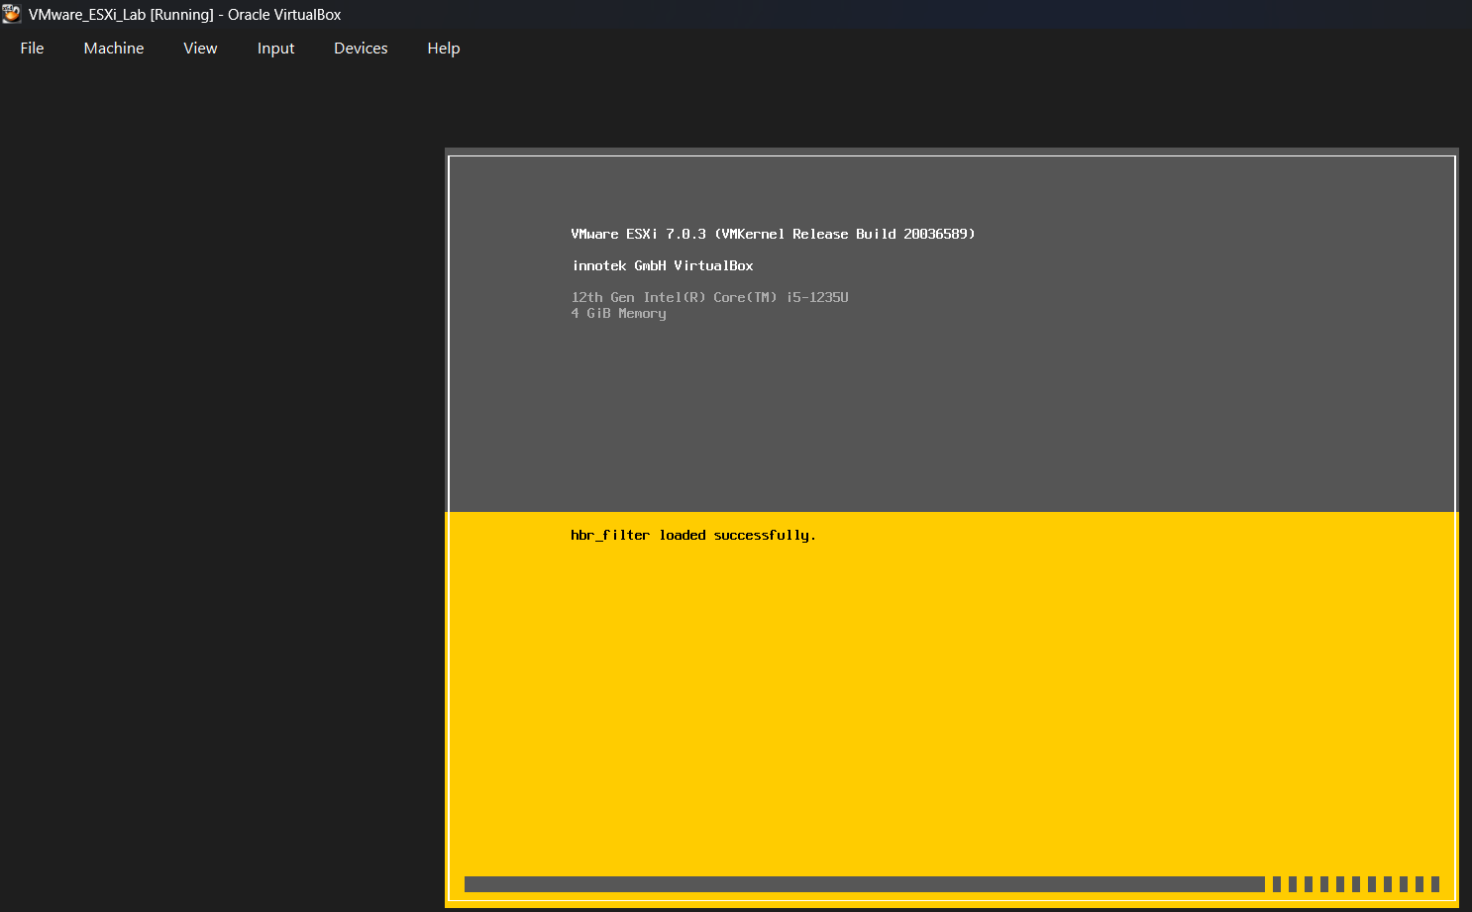

- Welcome Screen: Once it loads, press Enter to continue.
- EULA: Press F11 to Accept and Continue. (You may need to use Fn + F11 depending on your keyboard).
- Select a Disk: It will scan for storage and find the 20GB VirtualBox disk you created. Press Enter to install on this disk.
- Keyboard Layout: Select US Default and press Enter.
- Root Password: Type a strong password, confirm it, and press Enter. (Do not forget this password; there is no easy way to recover it).
- Confirm Installation: The system will warn you that the disk will be repartitioned. Press F11 to Install.
- Reboot: Once the installation reaches 100%, press Enter to reboot. (VirtualBox should automatically unmount the ISO, but if it boots back into the installer, power off the VM, remove the ISO from the Storage settings, and start it again).

Phase 4: Access the VMware Host Client (Web UI)
Once ESXi reboots, it will not drop you into a standard desktop. Instead, it boots into the Direct Console User Interface (DCUI), which is a static yellow and black screen.
- Look at the yellow and black DCUI screen. It will display a message like:
Download tools to manage this host from:
http://192.168.1.50 (Your specific IP address will be displayed here).
- Leave the VirtualBox VM running in the background.
- Open a web browser (Chrome, Edge, etc.) on your Windows PC.
- Type the IP address from the DCUI screen into the address bar and press Enter.
- Security Warning: Because ESXi uses a self-signed security certificate, your browser will warn you that the connection is not private. Click Advanced and then Proceed to 192.168.x.x (unsafe).
- Login: You will see the VMware ESXi welcome screen.
  - User name: root
  - Password: The password you created in Phase 3.
- Click Log in.
You are now inside the VMware Host Client. From this dashboard, you can explore how enterprise administrators allocate storage, create virtual switches, and deploy actual virtual machines inside the ESXi hypervisor.

